**Assignment 4: Harry Potter Reunion – Magical Transportation Network**

**Name: Hamza Siddiqui**

**UCID: 30183881**

**1. Graph Construction**

* **Nodes (Provinces):** Each Canadian province is represented as a node in the network where in each of the province, the Harry potter Alumni reside in and **Ottawa** as the reunion destination.
* **Edges (Magical Paths):** Each directed edge indicates a magical path between two provinces with associated attributes:
  + **Hops:** The number of intermediate steps.
  + **Distance:** In kilometers (km).
  + **Time:** In hours (hrs).
  + **Dementors:** A numerical danger level (the higher, the more dangerous).

We also abbreviated **Newfoundland and Labrador** to **NL** to reduce clutter in the graph.

**2. Pathfinding Methods**

For **each alumnus**, we compute four separate optimal paths to Ottawa using **two main pathfinding algorithms**:

1. **Breadth-First Search (BFS)** for the **Shortest Hop Path (SHP)**:
   * **SHP** looks for the path with the fewest edges (or “hops”).
   * BFS naturally finds the shortest route in an unweighted sense—i.e., it does not matter how long or dangerous the path is, only how many edges it uses.
2. **Dijkstra’s Algorithm** for the other three metrics (weighted paths):
   * **Shortest Distance Path (SDP):** Minimizes the total distance (sum of the edge distances).
   * **Shortest Time Path (STP):** Minimizes the total travel time (sum of the edge times).
   * **Fewest Dementors Path (FDP):** Minimizes the sum of the dementors along the path.

By passing a **different cost function** to Dijkstra’s algorithm (distance, time, or dementors), we get the respective optimal path.

**3. Subplots & Resulting Paths**

Each subplot in the figure shows the **entire magical transportation network** in gray (nodes and edges), **plus** the color-coded paths for every alumnus (Harry, Hermione, Ron, Luna, Neville, Ginny).

**3.1 Shortest Hop Path (SHP) [Top-Left]**

* Computed via **BFS**.
* The cost shown in the legend is **Hops**.
* Each alumnus’s path is color-coded and, if multiple alumni share edges, the arcs are offset so you can see distinct lines.
* This section ignores the actual distances, times, or dementors—only the number of edges is minimized.

**3.2 Shortest Distance Path (SDP) [Top-Right]**

* Computed via **Dijkstra’s** using **distance** as the cost function.
* The cost shown in the legend is **km**.
* Alumni who start close to Ottawa (or have short-distance routes) might share edges if it reduces the total kilometers traveled.

**3.3 Shortest Time Path (STP) [Bottom-Left]**

* Computed via **Dijkstra’s** using **time** (hrs) as the cost.
* The cost shown in the legend is **hrs**.
* Some routes might be longer in distance but still have lower travel hours (maybe they have fewer intermediate stops or faster magical links).

**3.4 Fewest Dementors Path (FDP) [Bottom-Right]**

* Computed via **Dijkstra’s** using **dementors** as the cost.
* The cost in the legend is **just an integer** (no units).
* Alumni typically avoid edges with high dementor counts, even if the route is longer or slower.

**4. Features**

* **Graph Representation:**Provinces are modeled as nodes and magical paths (with attributes such as hops, distance, time, and number of dementors) as edges.
* **Visualization:**The network is visualized using **NetworkX** and **Matplotlib** in a 2×2 grid of subplots—one subplot for each optimal path criterion.
  + Each alumnus’s optimal path is drawn in a unique color with an arc offset to prevent overlapping.
  + Bold edge labels (displaying the distance in km) are drawn on top of the colored paths.
  + Legends (placed outside the plot area) indicate the alumnus’s name, starting province, and the cost with appropriate units (Hops, km, hrs, or no unit for Dementors).

**5. Code Overview**

* **Graph Construction:**  
  The MagicalGraph class represents provinces as nodes and magical paths as edges. Data from the table is used to build the graph.
* **Pathfinding Algorithms:**
  + **BFS** is used for SHP (minimizing hops).
  + **Dijkstra’s algorithm** (with different cost functions) is used for SDP (minimizing distance), STP (minimizing time), and FDP (minimizing dementor exposure).
* **Visualization:**  
  The function visualize_all_alumni_paths() converts the custom graph to a NetworkX graph, calculates positions using Kamada-Kawai (or Spring layout as fallback), and draws each optimal path with a unique color and offset arcs to avoid overlapping. Bold edge labels display the distance, and legends show detailed information for each alumnus.

**6. General Observations in the Figure**

* **Shared Edges:** You can see some arcs in the same color overlapping for a while before diverging—this indicates multiple alumni traveling along the same edge for a portion of their journey.
* **Differing Costs:** An alumnus may choose a different route for distance vs. time vs. dementors vs. hops. This is why the same alumnus can have four very different colored routes across the subplots.
* **No Overlap from Certain Provinces:** If an alumnus’s best path doesn’t pass through a particular province or edge, it remains gray in that subplot.

**7. Results: Optimal Paths for Each Alumnus:**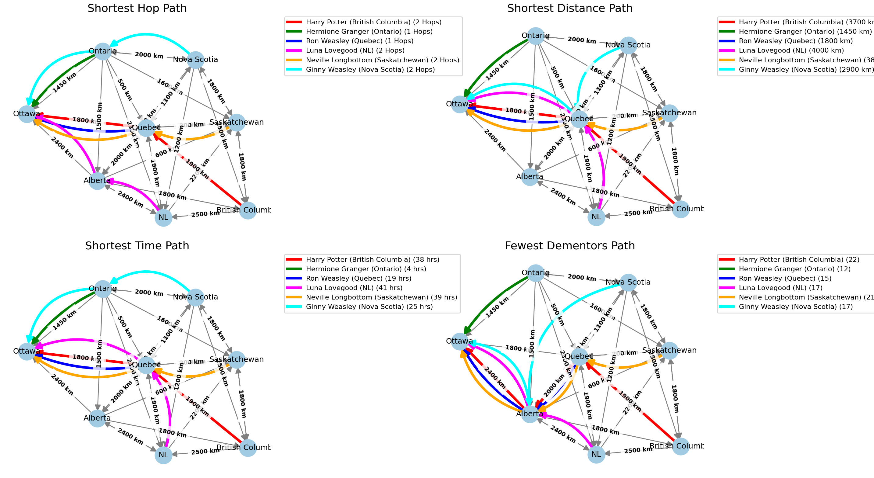

**Harry Potter (British Columbia → Ottawa)**

**SHP:** British Columbia → Quebec → Ottawa | Hops: 2  
**SDP**: British Columbia → Quebec → Ottawa | Distance: 3700 km  
**STP**: British Columbia → Quebec → Ottawa | Time: 38 hrs  
**FDP:** British Columbia → Quebec → Alberta → Ottawa | Dementors: 22

**Hermione Granger (Ontario → Ottawa)**

**SHP:** Ontario → Ottawa | Hops: 1  
**SDP:** Ontario → Ottawa | Distance: 1450 km  
**STP:** Ontario → Ottawa | Time: 4 hrs  
**FDP:** Ontario → Ottawa | Dementors: 12

**Ron Weasley (Quebec → Ottawa)**

**SHP:** Quebec → Ottawa | Hops: 1 **SDP**: Quebec → Ottawa | Distance: 1800 km  
**STP**: Quebec → Ottawa | Time: 19 hrs  
**FDP:** Quebec → Alberta → Ottawa | Dementors: 15

**Luna Lovegood (Newfoundland and Labrador → Ottawa)**

**SHP:** NL → Alberta → Ottawa | Hops: 2  
**SDP**: NL → Quebec → Ottawa | Distance: 4000 km **STP:** NL → Quebec → Ottawa | Time: 41 hrs  
**FDP**: NL → Alberta → Ottawa | Dementors: 17

**Neville Longbottom (Saskatchewan → Ottawa)**

**SHP:** Saskatchewan → Quebec → Ottawa | Hops: 2  
**SDP:** Saskatchewan → Quebec → Ottawa | Distance: 3800 km **STP:** Saskatchewan → Quebec → Ottawa | Time: 39 hrs  
**FDP:** Saskatchewan → Quebec → Alberta → Ottawa | Dementors: 21

**Ginny Weasley (Nova Scotia → Ottawa)**

**SHP**: Nova Scotia → Ontario → Ottawa | Hops: 2 **SDP:** Nova Scotia → Quebec → Ottawa | Distance: 2900 km **STP:** Nova Scotia → Ontario → Ottawa | Time: 25 hrs  
**FDP:** Nova Scotia → Alberta → Ottawa | Dementors: 17

**8. Challenges and problems faced:**

Initially the format wasn’t clear and was confusing when the graph was drawn so I decided to highlight the different provinces edges with different colors so that it is more clear using the Kamada-Kawai layout.

This way the graph looked nice and pretty as well as it wasn’t confusing.

The arrows or edges that were leading up to Ottawa sometimes caused the other edges to be hidden since they were overlapping so I decided to add curvature and so that all arrows (edges) can be shown when going to the same place.

Although the table we have is very unique and helpful, some strings like ‘Newfoundland and labrador’ was obstructing other nodes and tables and was occupying a lot of space since the string was too long so we decided to abbreviate the string into ‘NL’.

**9. Summary**

1. **BFS** is used for the **Shortest Hop Path**, focusing solely on the number of edges and **BFS** is best for calculating short path in an unweighted graph which is when every edge is considered equal where we aren’t caring about any other facts than the number of hops (edges) taken.
2. **Dijkstra’s Algorithm** is used for the **Shortest Distance**, **Shortest Time**, and **Fewest Dementors** paths. Each criterion changes the cost function.
3. **Offset arcs** and **color-coding** ensure clarity when multiple alumni share edges.
4. The final subplots show the optimal routes for all alumni, with the total cost (hops, km, hrs, or dementors) displayed in the legend for each alumnus.

Overall, these paths highlight how optimizing for different metrics leads to different routes for each alumnus, depending on whether they want to minimize hops, distance, time, or dementor exposure.